

**EMPLOYEE TIME ENTRY SYSTEM**

**PRESENTED BY**

Chigurukota Aasritha sai

**Introduction to the Time Entry System**

The time entry system is crucial for tracking and managing employee work hours. It encompasses a range of features to streamline the process of recording work hours, including clocking in and out, entering time for specific projects, and managing time off. By providing tools for planning, tracking, and analysing time-related activities, these systems contribute to the success of both individuals and organisations in achieving their goals.

**Purpose and Benefits of the System**

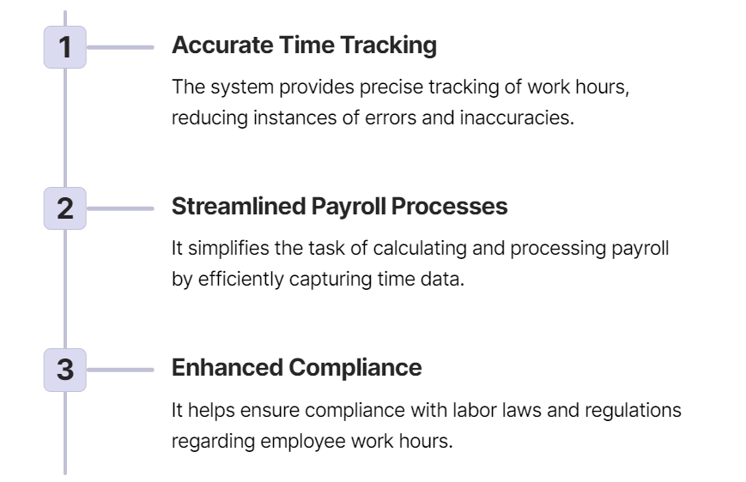

**Requirements**

Front End: React JS, CSS, Bootstrap

Back End: Java

Database: Express and node JS

**User Interface and Navigation**

The system boasts an intuitive and user-friendly interface, providing employees easy access to time-related functions. Its navigation is designed for simplicity, ensuring seamless movement between sections.

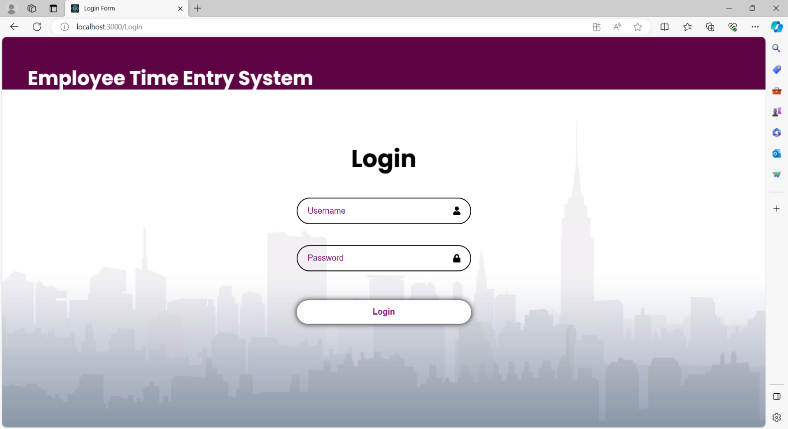Firstly, when accessing the React Application, the first page of the application is the “Login Form”.

The Login Form will navigate to the next page, only when the credentials entered by the employee are correct.

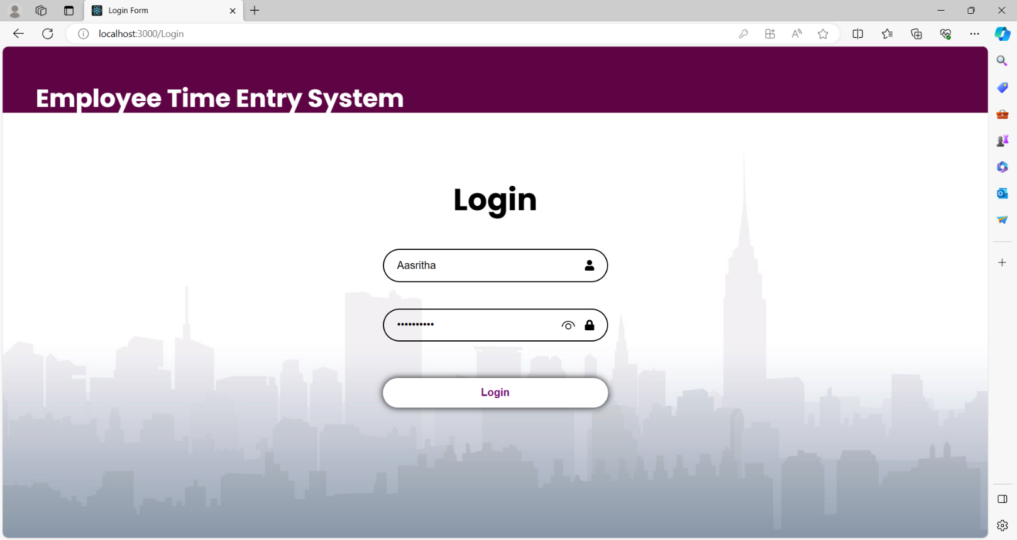

After validating the credentials, the login page gets navigated to the “Week view” page of the application.

* The Week view page consists of 2 links at the top of the container named “Week view” and “Month view”.
* When an employee clicks on the Week view, there will be no change.

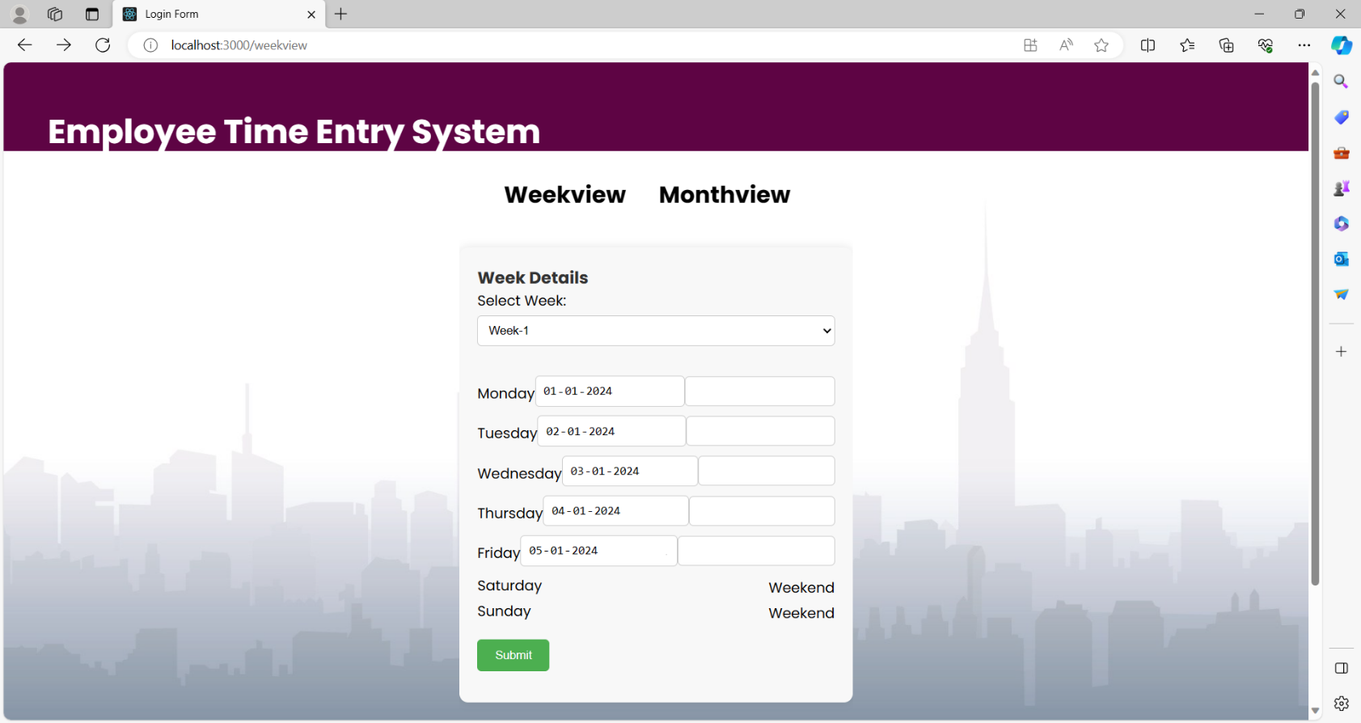



* The Dates of the week change accordingly, after selecting the week.



* Now employees can add the details regarding the number of hours worked on a particular date in the text box.
* Saturday and Sunday are marked as Weekend.
* Onclick on the Submit button, the data submitted is displayed at the bottom of the week box.

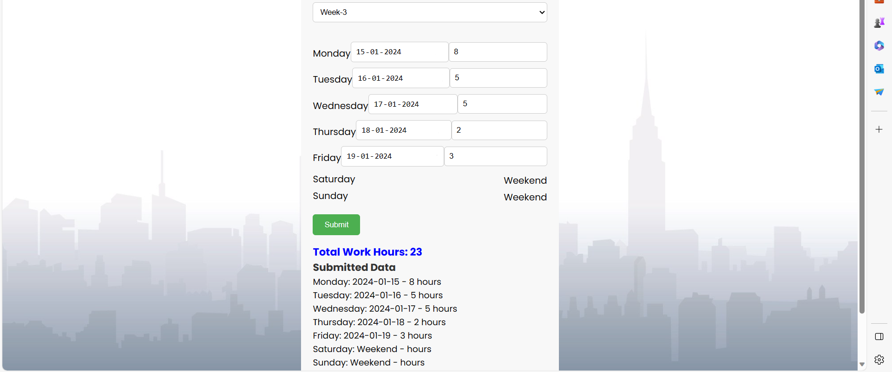

* 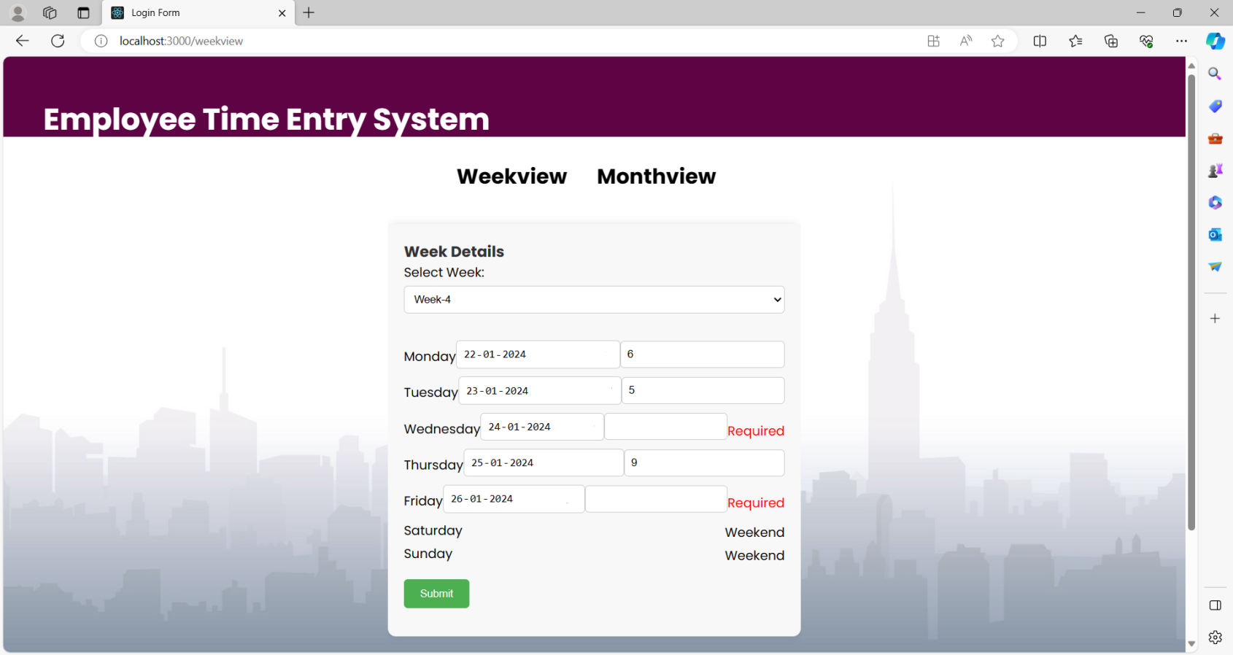The system validates the daily data inputted by employees to ensure completeness and accuracy.
* 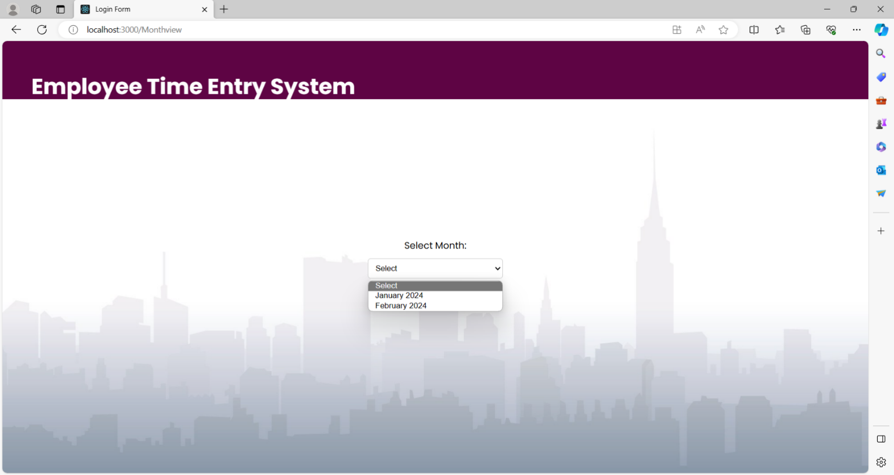Clicking on Month view navigates to the Month view page.
* Upon selecting a specific month, the page will automatically redirect to the corresponding dates of the chosen month.
* Each day in the January month is represented with a text box where employees can add the details regarding the number of hours worked on a particular date in the text box.
* Onclick on the Submit button, the total number of hours worked in that particular month is displayed at the bottom.

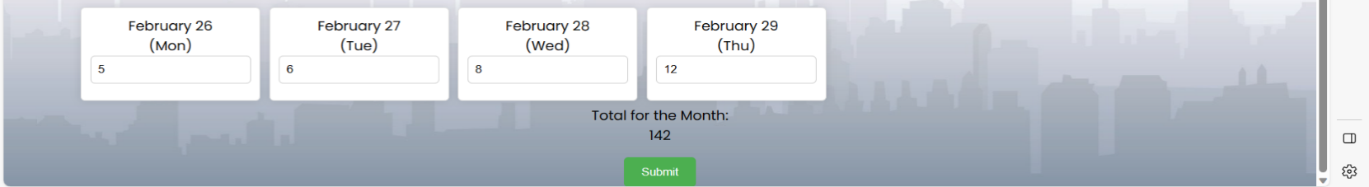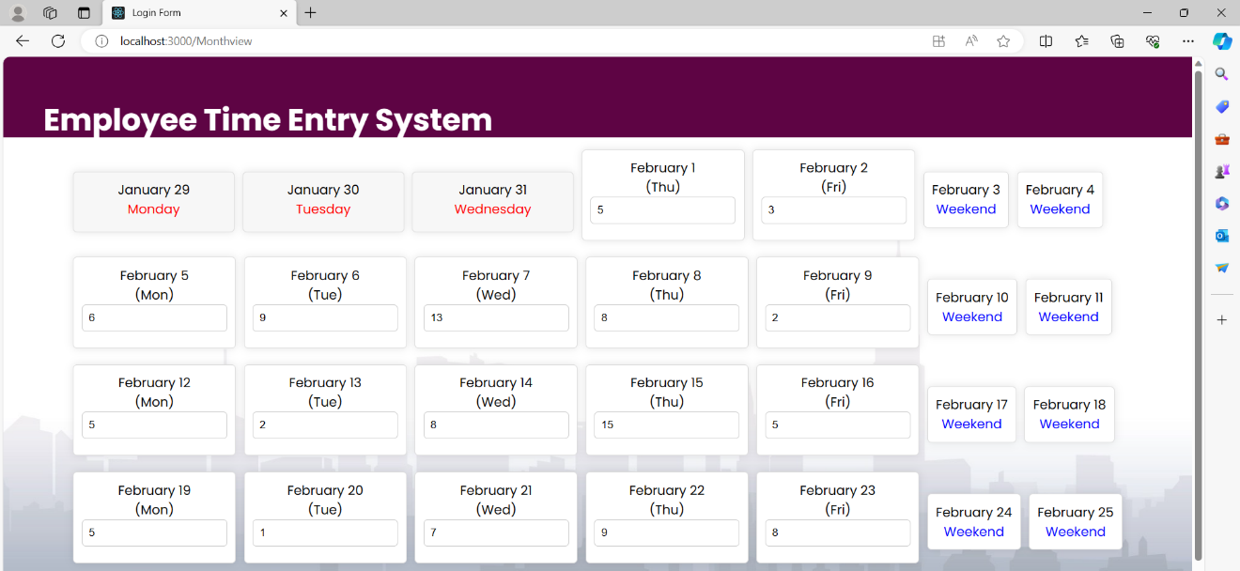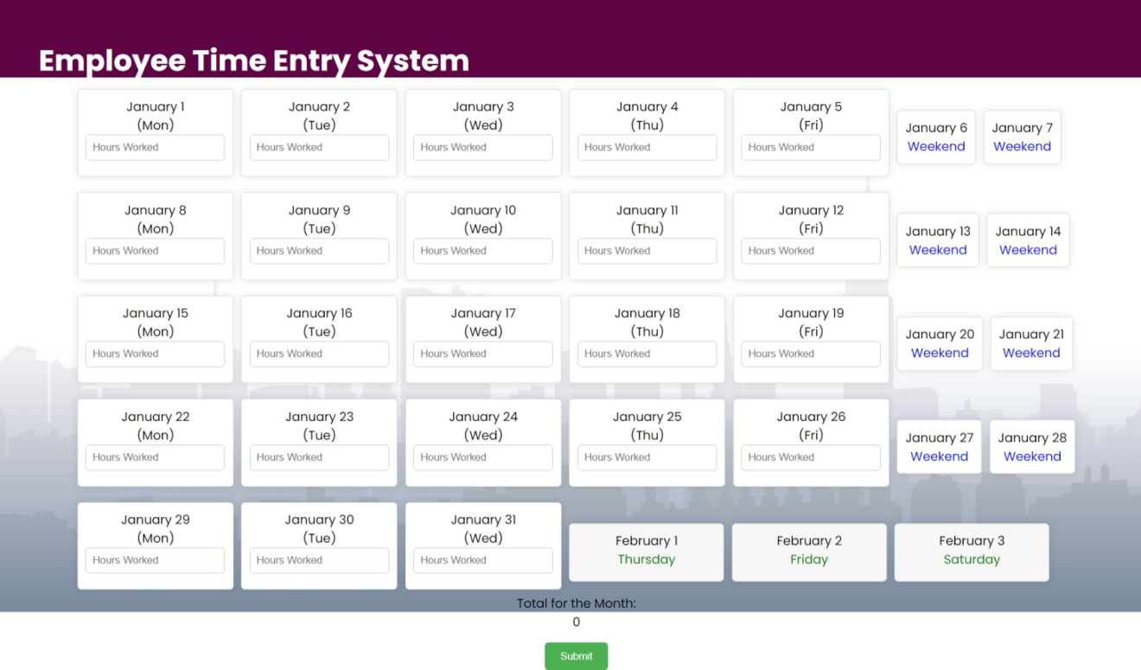

* The system has been designed to validate the daily data inputted by employees to ensure that all the fields are complete before submission.
* In case any of the fields are left empty, the submit button will be disabled until the employee inputs data for all the fields. This feature has been incorporated to ensure data accuracy and completeness while streamlining the data entry.

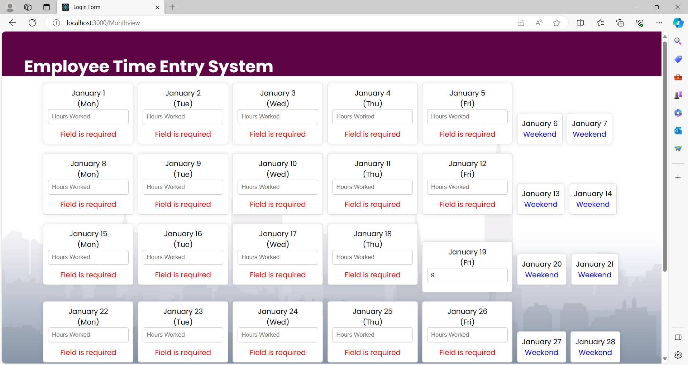

* Upon clicking the 'submit' button located on both the week view and month view pages, the details entered by an employee are automatically stored in the database for record-keeping purposes.

**GitHub Link**

<https://github.com/Aasritha26/Time-Entry-System>

**Web application Link**

<http://192.168.1.38:3000/login>